Name_______________________________________________

I can compare stories

|  |  |  |
| --- | --- | --- |
| Rate yourself | http://www.harpercollinschildrens.com/harperchildrensImages/isbn/large/9/9780688152819.jpg | http://img1.fantasticfiction.co.uk/images/n26/n132918.jpg |
| Who are the characters? |  |  |
| What is the setting? |  |  |
| What happened?  (plot/major events) |  |  |

I can compare stories

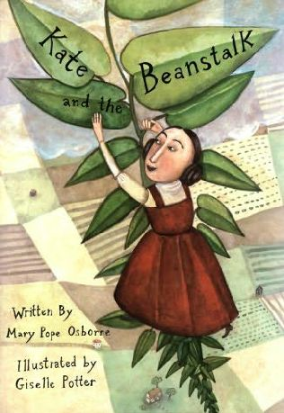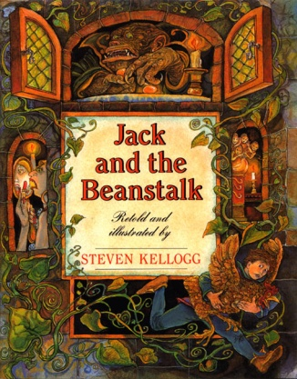

Same Different